Introduction | In these activities, students will explore the data that they gathered with Splash! and apply it to various mathematical tasks.
Time | Approximately 90 minutes
Grade | 9-12
Lesson  Preparation | Students will have visited the Tsongas Industrial History Center to participate in the Power to Production program. Students gathered data from the waterwheel test on the Splash! app.  For this activity, teachers can download the class’s data at www.tihcsplash.org.  Download the waterwheel videos from the TIHC YouTube page:  https://www.youtube.com/watch?v=rHXmdO3oV1A (Bucket Red Wheel)  https://www.youtube.com/watch?v=KGOGiUczefM (Paddle Blue Wheel)  Copies of the Waterwheel Images.
Vocabulary | Volume  Speed  Rotation  Prism
Anticipated Student Preconceptions/ Misconceptions | Students will need to know how to find the volume of a right rectangular prism having trapezoidal bases. Students will need to utilize proportional reasoning, as the areas of the paddle wheels do not fill up entirely
Frameworks | Massachusetts Math Standards  G.MG. Apply geometric concepts in modeling situations.  1. Use geometric shapes, their measures, and their properties to describe objects (e.g., modeling a tree trunk or a human torso as a cylinder).  2. Apply concepts of density based on area and volume in modeling situations (e.g., persons per square mile, BTUs per cubic foot).  3. Apply geometric methods to solve design problems (e.g., designing an object or structure to satisfy physical constraints or minimize cost; working with typographic grid systems based on ratios).  MA.4. Use dimensional analysis for unit conversions to confirm that expressions and equations make sense.

Guiding Question | What volume of water is moved by the wheel every minute?
Objectives | Students will be able to use volume formulas and estimation to create a model that can be used to determine the volume of water moved by a given wheel/base combination in one minute.
Activity | - Group students in teams of three or four.  - Show the data they gathered during their field trip. Remind students of the different types of wheel and base combinations (red is bucket, blue is paddle).  - Show students the video of the two wheels in the high breast base and present the guiding question.  - Provide a copy of one of the two wheel diagrams including dimensions of the wheel (both wheels have an 18” diameter).  - Ask students questions such as  - What information do you need to know to solve this?  - What formulas could be helpful?  - What quantities can you estimate by watching the video?  - How is this problem different if a bucket wheel is used rather than a paddle wheel?
Assessment | Assessment will be done through student presentations, either written or oral.
Differentiated Suggestions | Provide a list of resources and/ or formulas for students.  Encourage students to extend the activity and consider the effects that different bases would have on the amount of water that would be moved.

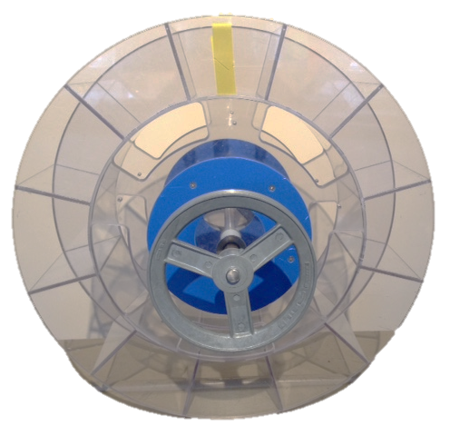
Waterwheels
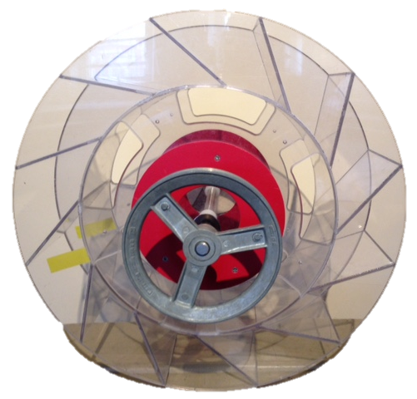
Paddle Wheel
Bucket Wheel

